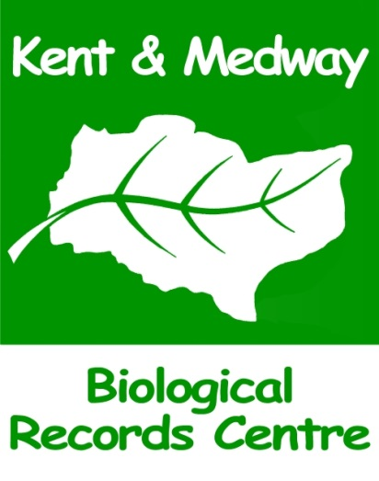

Data Search Charges
Last updated 01/11/19

Charges
- Please note: The charges shown below will apply as from 1st November 2019. All data search requests received before that date will be processed at the current charging rate.

Standard reports (supplied in PDF format):
- Map of statutory and non-statutory designated sites accompanied by statutory citations
- Protected Species Inventory including KRAG data (excludes bats and birds)
Conservation Concern Species Inventory (NERC, Section 41 and BAP priority
species.
- Invasive non-native species Inventory
- Kent Rare and Scarce Species Inventory (excludes bats and birds)
- Bat Records from Kent Bat Group, including a bat roost map
- Bird Records from Kent Ornithological Society, including an indication of breeding status

Administration charge for standard data search report not exceeding 50km² to include all items listed above | £280 + VAT
Large Area surcharge (over 50km² up to a maximum of 100km²) | +20%
Administration charge for any one species report for an area not exceeding 50km² | £140 + VAT
Charge for Habitat and BAP Habitat Maps | £20 + VAT each
Charge for SSSI Risk Zones Report and Map | £30 + VAT
Discount for data searches which result in a complete absence of data | -50%
Priority Fee for 24 hour turnaround | +20%

* for search areas greater than 100km² please contact KMBRC for a quote

Provision of Data in GIS Shapefile Format

In some circumstances it may be possible to supply data in GIS shapefile format where our standard search would not be applicable or suitable, for example; where data is required for the route of a proposed powerline or pipeline covering a considerable distance.

All requests for data in GIS shapefile format will be considered individually and costs will be dependent on the specific requirements of those individual search requests. If you require data in this format please contact us to discuss whether we may be able to help.

Exemptions from payment

- Enquiries received from the general public are normally free of charge for the first hour of work. This is usually the equivalent of one standard data search request. Enquiries on a larger scale will be discussed individually and either the scope of enquiry reduced or a charge may be levied. It should be noted that no enquiry data received under this exemption should be used for commercial purposes, including planning applications. If this is intended, then a payment must be made.

- Searches on behalf of species recording groups and individual recorders who have a data exchange agreement with us are free of charge. Data processing, manipulation and interrogation facilities are available to the recording groups and individuals, under the provision of the 'technical support for recording groups’.

- No charge is made to KMBRC Service Level Agreement (SLA) Partners. This also applies to their contractors, but contact details must be given on the relevant section of the information request form so that we can contact the partner for authorisation prior to proceeding with the work.

